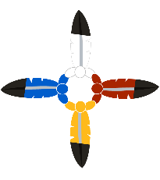 RESEARCHER APPLICATION
Nanaandawewigamig
First Nations Health and Social Secretariat of Manitoba
Health Information Governance Committee (HIRGC)
Date of Application:
Purpose of Application (What are you seeking from HIRGC) Please Circle One:
Advice Letter of Support Partnership/Collaboration Other (Please State):
Contact Information
Name of Researcher:
Address:

Phone:
Fax:
E-mail:

Title of Research Project
Project Timeframe:

Members of Research Team

Purpose of Research Project

Brief Description of Methodology (Please use clear, layman’s English – define any medical or other terms)

Benefit to First Nations & Manitoba First Nations – Including direct benefits of First Nations Participation on Advisory Committee and/or Project Team
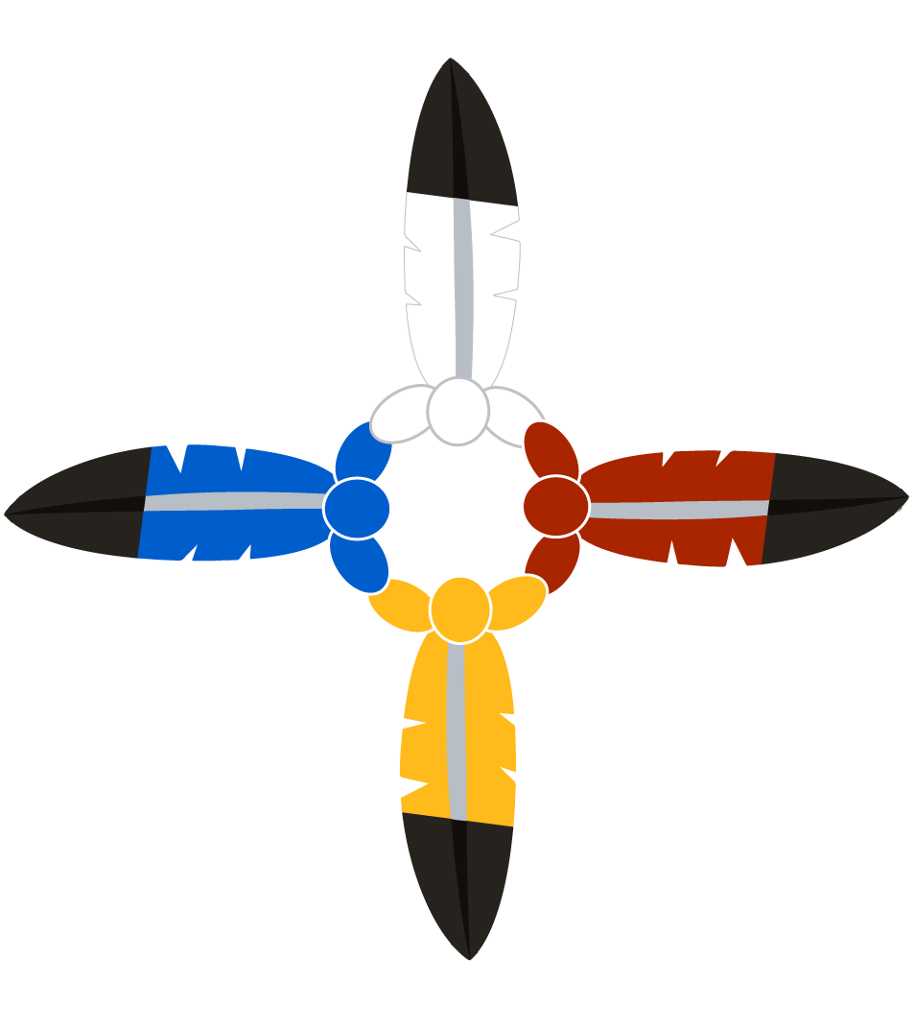

RESEARCHER APPLICATION
Nanaandawewigamig
First Nations Health and Social Secretariat of Manitoba
Health Information Governance Committee (HIRGC)

Involvement of Manitoba First Nations – Ongoing & Proposed
i.e. involved in research design, research team, staffing, advisory or oversight committee members, etc.

Evidence of following the Chiefs requirements for Respectful Research
Free, Prior, Informed Consent (individual & collective i.e. participants and Chiefs & Councils):
First Nations OCAP ( Applying Principals - Ownership, Control, Access, and Possession):
Ethical Standards of First Nations:
“Research is a relationship based on respect and it takes time to build a relationship”
Manitoba First Nations Elders 2005 Workshop on Health Research Ethics

Please attach your submission to and proof of review by external Ethics Boards
(Such as UM HREB, Manitoba Health HIP-C, Health Canada REB, or others) proposal and application for funding.
Contact Information:
Nanaandawewigamig
First Nations Health and Social Secretariat of Manitoba
Suite 600 - 275 Portage Avenue
Winnipeg, MB R3B 2B3
Phone: 204.942.9400 Fax: 204.946.9768
Leona Star, Indigenous Research Lead
lstar@fnhssm.com
Leanne Gillis, Community Liaison/Administrative Assistant
lgillis@fnhssm.com

